**9) Explain the steps to create bar chart and pie diagram in tableau with example (With the**

**help of an example create one in tableau)**

**Bar Chart:**

**Step 1: Connect to Your Data:**

* Open Tableau and connect to your data source.

**Step 2: Drag Dimensions and Measures:**

* Drag the dimension you want to represent on the x-axis to the Columns shelf.
* Drag the measure you want to represent on the y-axis to the Rows shelf.

**Step 3: Choose the Bar Chart Type:**

* In the Show Me menu on the top-right, select the "Bar" chart type. This will transform your data into a bar chart.

**Step 4: Customize the Chart:**

* Customize the appearance of your bar chart by adjusting colors, labels, tool-tips, and formatting options.

**Step 5: Add Labels:**

* Drag the dimension or measure you want to use for labeling to the Label shelf.

**Example:**

* Suppose you have a data set with sales data by product category. You can create a bar chart by placing the product category on the Columns shelf and sales on the Rows shelf.

**Pie Chart:**

**Step 1: Connect to Your Data:**

* Open Tableau and connect to your data source.

**Step 2: Drag Dimensions and Measures:**

* Drag the dimension you want to represent in the pie chart to the Color or Angle shelf.
* Drag the measure you want to represent as the size of the slices to the Size shelf.

**Step 3: Choose the Pie Chart Type:**

* In the Show Me menu on the top-right, select the "Pie" chart type. This will transform your data into a pie chart.

**Step 4: Customize the Chart:**

* Customize the appearance of your pie chart by adjusting colors, labels, tool-tips, and formatting options.

**Step 5: Adjust Slices:**

* If needed, adjust the slices by dragging fields to the Label or Tool tip shelves.

**Example:**

Suppose you have a data-set with sales data by region. You can create a pie chart by placing the region on the Color shelf and sales on the Size shelf.

**In Tableau:**

**Prerequisites**: Superstore Data-source provided by Tableau, which includes three tables: orders, people, and returns.

**Orders Table**:

Columns: Order ID, Order Date, Ship Date, Ship Mode, Customer Name, Segment, Country/Region, City, State, Province, Category

**People Table**:

Columns: Regional Manager

**Returns Table**:

Columns: Returned

* Select State/Province in Dimensions and drag it to columns and filter data by Canadian country.
* Select Profit and drag it to rows.
* Change Mark to bar.

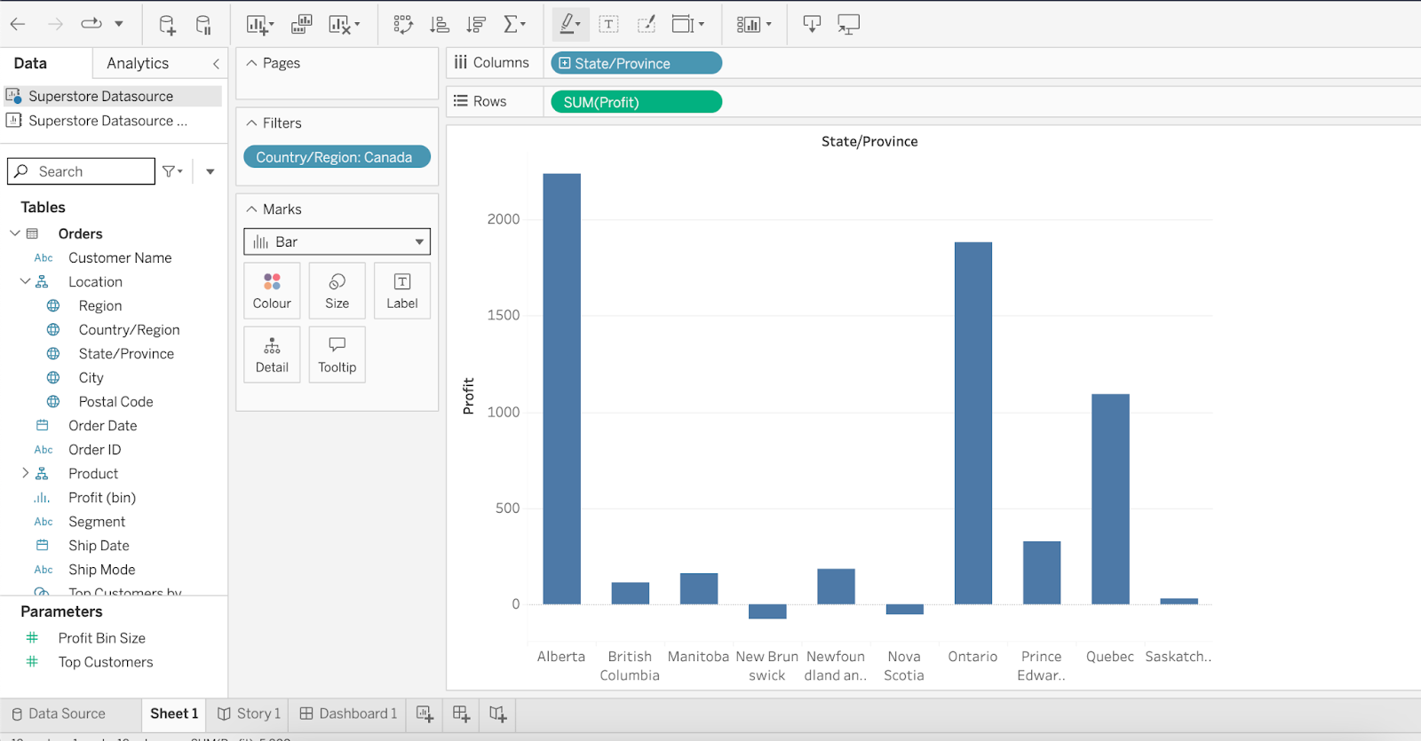

* **To Create a pie follow the below steps:**
  + Select Category dimension to color and detail.
  + Select sum and drag it to Pie.
  + On the top right click on show me and change the chart type to pie.

